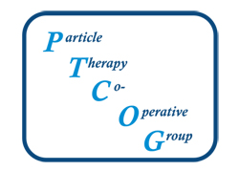

PTCOG project funding 2024

Title

Acronym

Proposal topic:
Medicine
Physics
Radiobiology

New proposal
Renewal

Authors (if renewal, indicate change in investigators)

Affiliations

Corresponding author (including address, telephone and email)

Abstract (max 200 words)

Proposed activity

Relevance to the field

Previous results (only for renewal proposals)

Timetable (please provide at least 2 milestones at different months; max duration is 1-year. The authors can re-apply for a second year as an extension)

Budget (the total budget should not exceed a total of 25 k€)

Deliverables (e.g., expected publications)

All proposals will be reviewed by expert reviewers and ranked based on their scientific merit
It is expected that the results of the research will be presented at the next PTCOG annual meeting. PTCOG will partially support travel to the meeting.
Publications resulting from this research should acknowledge funding by PTCOG.

Please consult the PTCOG President for any questions.

